**File Handling using Client-Server Application.**

**FileServer.java**

1. package FileServer;
2. import java.io.*;
3. import java.net.*;
4. public class FileServer {
5. public static void main(String[] args) throws IOException {
6. ServerSocket ss = new ServerSocket(777);
7. Socket s = ss.accept();
8. BufferedReader br = new BufferedReader(new InputStreamReader(s.getInputStream()));
9. DataOutputStream out = new DataOutputStream(s.getOutputStream());
10. String fname= br.readLine();
11. System.out.println("Client Says : "+fname);
12. FileReader fr = null;
13. BufferedReader file = null;
14. boolean flag;
15. File f = new File("D:\\"+fname);
16. if(f.exists())
17. flag = true;
18. else
19. flag = false;
20. if(flag == true)
21. {
22. out.writeBytes("yes"+ "\n");
23. }
24. else
25. {
26. out.writeBytes("no"+"=\n");
27. }
28. if(flag == true)
29. {
30. fr = new FileReader("D:\\"+fname);
31. file = new BufferedReader(fr);
32. String str;
33. while((str=file.readLine())!=null)
34. {
35. out.writeBytes(str + "\n");
36. }
37. file.close();
38. out.close();
39. br.close();
40. fr.close();
41. s.close();
42. ss.close();
43. }
44. }
45. }

**FileClient.java**

1. package FileServer;
2. import java.io.*;
3. import java.net.*;
4. public class FileClient
5. {
6. public static void main(String[] args) throws IOException
7. {
8. Socket s = new Socket("localhost",777);
9. BufferedReader br = new BufferedReader(new InputStreamReader(System.in));
10. System.out.println("Enter File name : ");
11. String fname = br.readLine();
12. DataOutputStream out = new DataOutputStream((s.getOutputStream()));
13. out.writeBytes(fname+"\n");
14. BufferedReader in = new BufferedReader(new InputStreamReader(s.getInputStream()));
15. String str;
16. str = in.readLine();
17. System.out.println("Server Says : "+str);
18. if(str.equals("yes"))
19. {
20. while((str= in.readLine())!=null)
21. {
22. System.out.println(str);
23. }
24. br.close();
25. in.close();
26. s.close();
27. }
28. else
29. {
30. System.out.println("File not Found..");
31. }
32. }
33. }

**OUTPUT**

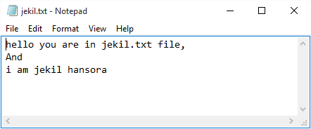

**Jekil.txt**

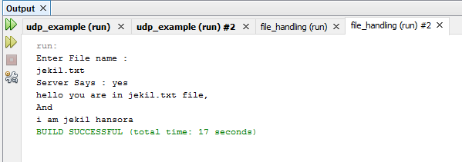

**Client**

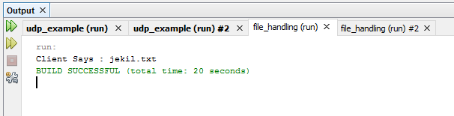

**Server**